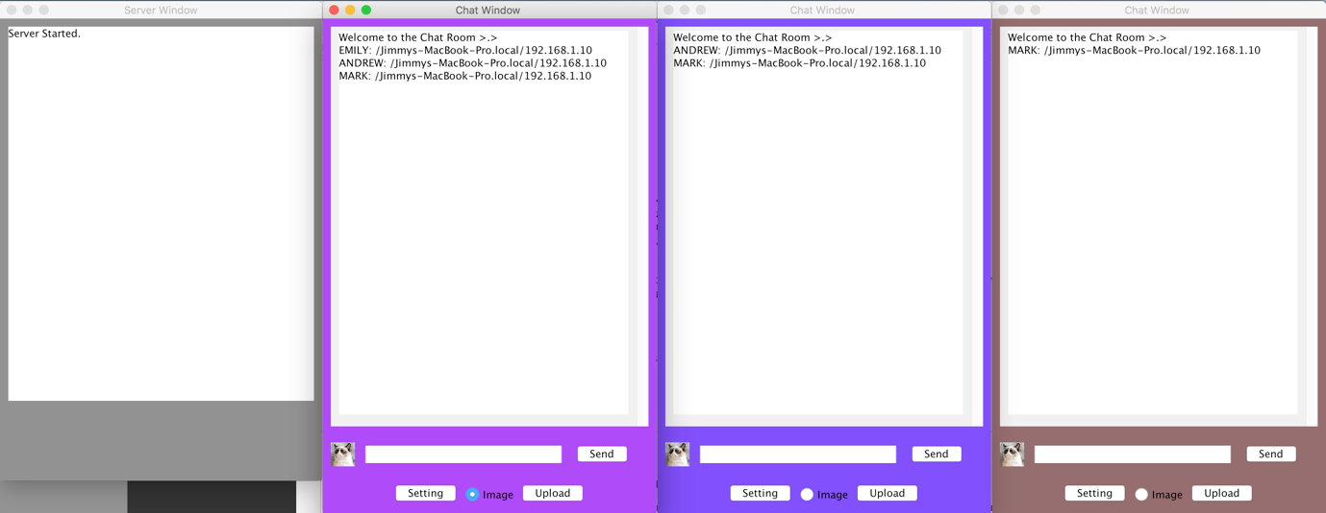

Figure : All chats joined the server

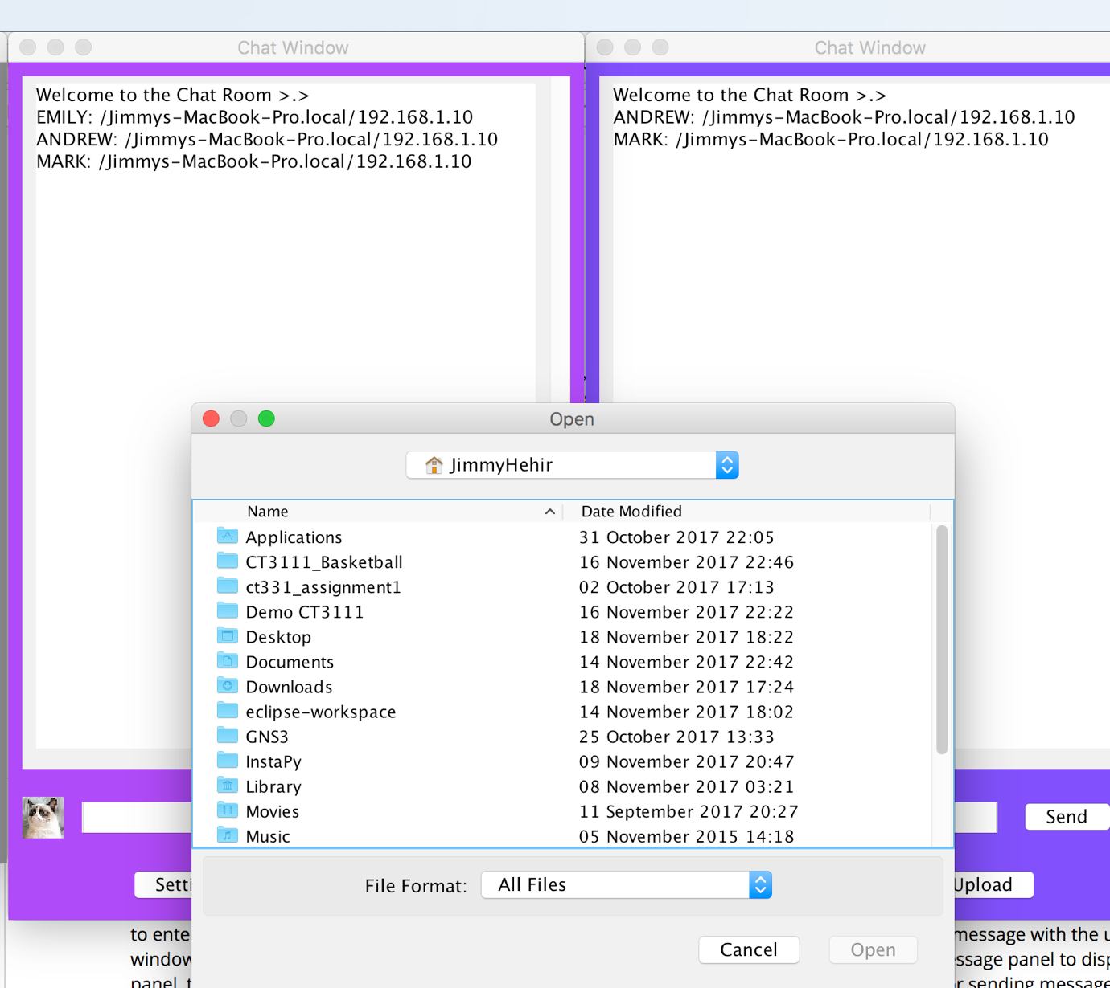

Figure : Send image to server

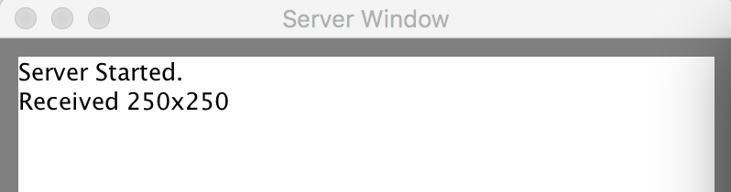

Figure : The server acknowledges the size for the file

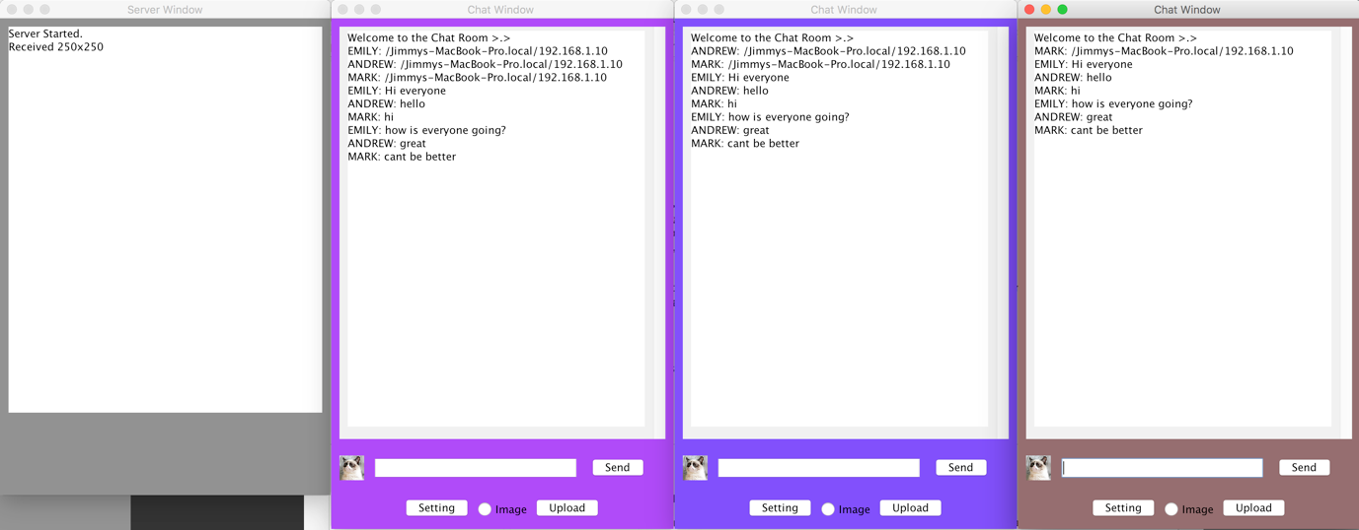

Figure : General conversation on the chat